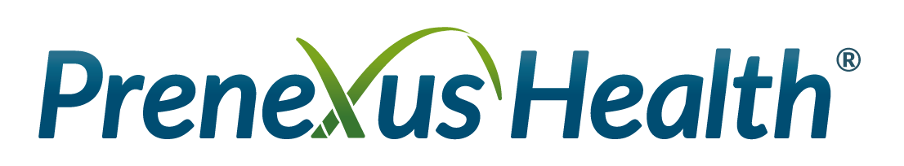

New Report Spotlights Trend Twist:
Medicinal Mushrooms for Digestive Health

GILBERT, Ariz., March 15, 2022-- Prenexus Health®, a leading manufacturer of organic prebiotic ingredients for the supplement, food and beverage industry today announced the release of its new report titled, “The Shroom Boom: Functional Fungi for Digestion.” The report unveils why the medicinal mushroom market continues to grow post-Covid and how fungi is teaming up with digestive health to satisfy consumer demand.

Both the Medicinal Mushroom category and the Prebiotic market are significantly growing, confirming the need for more options in the marketplace to satisfy a growing consumer demand. “Shroom Boom” looks at why consumers are turning to these two markets, especially Millennials, and how the marketplace is responding with innovative products.

“We see the pairing of medicinal mushrooms and prebiotics offering tremendous promise for health solutions and innovation in the digestive health category. We hope this new report offers new insights and solutions,” said Mike Bush, CEO of Prenexus Health.

The report also covers new ingredient formulations offering CPG manufacturers turnkey solutions to launch products that merge digestive health with functional fungi. These solutions are science-backed, non-GMO, made in the USA, organic, and formulation friendly with low inclusion rates. Inside also find five product possibilities that give manufacturers inspiration for new SKUs featuring mushrooms and prebiotics.

The white paper is part of the company’s robust industry and consumer education platforms that include Prebiotics.com, a consumer-facing website designed to educate and promote awareness about prebiotics.

Download the free report here.

For additional information and media inquiries, please contact Erin Miller, Prenexus Health Director of Marketing at emiller@prenexushealth.com or by phone at (216) 538-9633.

#

About Prenexus Health
Prenexus Health is an innovative leader in the development of scientifically based and clinically researched prebiotics. Based in Gilbert, Arizona, Prenexus Health's mission is to promote health and wellness for all people through consumer education, leading-edge research and development, and the responsible production of branded, clean label, certified organic prebiotic ingredients for dietary supplement, food and beverage products.

Prenexus' flagship ingredient, PreneXOSTM is a xylooligosaccharide (XOS) prebioticand is the only domestically produced organic XOS on the market. It is derived from high-fiber sugarcane grown in the Imperial Valley of California, following sustainable and environmental farming practices. PreneXOS has the ability to selectively feed "friendly" bacteria, at a low-effective inclusion rate.

Prenexus’ MyceliaGITM is a clean-label, shelf-stable, proprietary mushroom prebiotic that is also grown in the United States and can easily be incorporated into a variety of supplement, foods, and beverage applications. Unlike other mushroom products on the market, MyceliaGI is effective at low doses—500 mgs to 1.5 grams and is well tolerated by users.

